# CS 255 System Design Document Template

## UML Diagrams

### UML Use Case Diagram

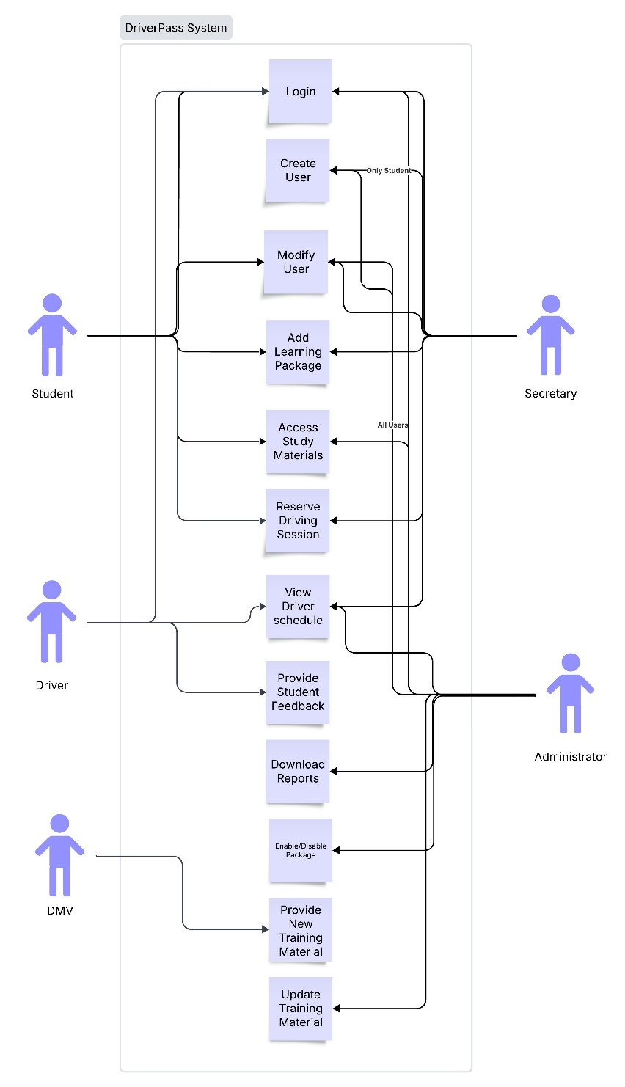

### UML Activity Diagrams

### UML Sequence Diagram

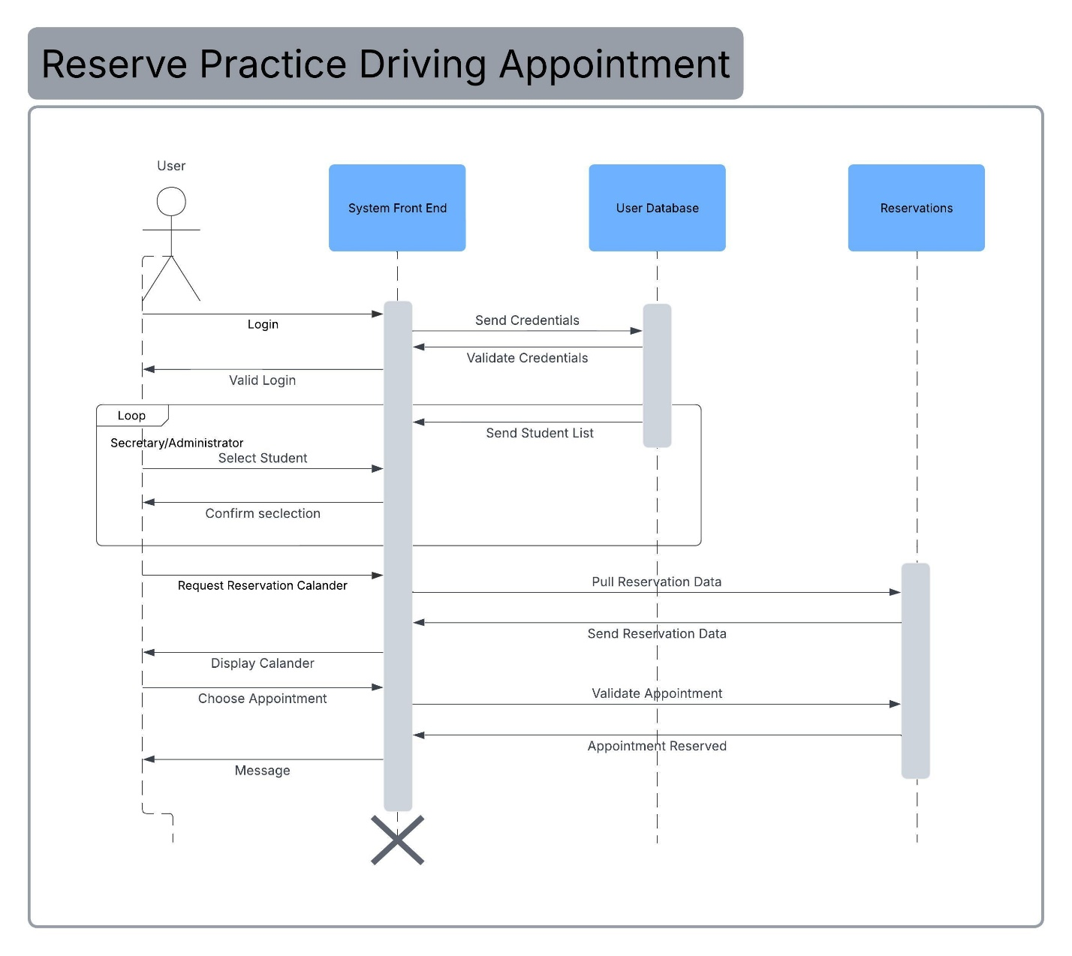

### UML Class Diagram

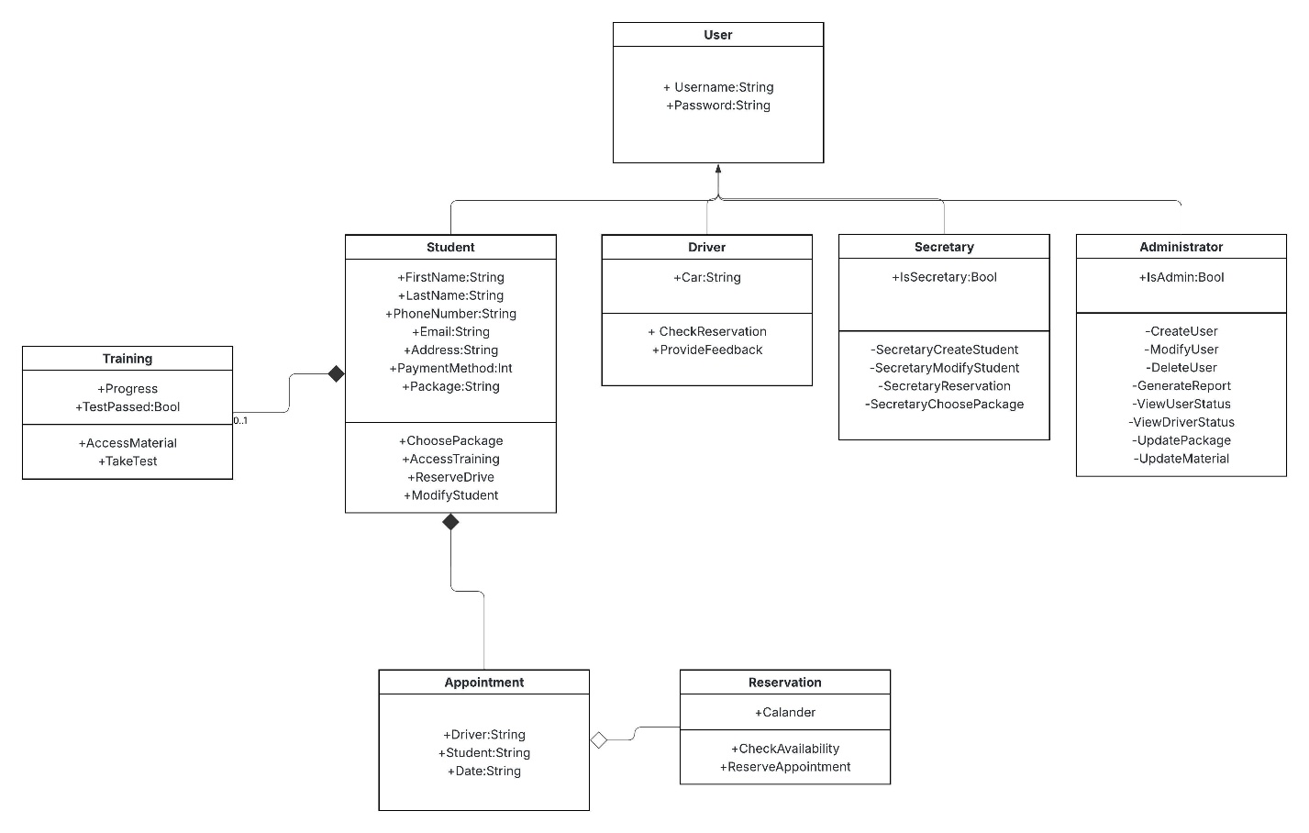

## Technical Requirements

**System Requirements**

**Hardware**

* Webserver with backup for 24/7 function
* 24/7 high speed internet connection at minimum 300 Megabits per second download and upload.
* At minimum 2 terabytes of storage capacity

**Software**

* Windows based server environment
* PCI Compliant data encryption for payment information and other User information
* Front-end DriverPass system software for deployable for connecting users
* Back-end DriverPass system logic for access information and databases
* User database
* Reservation database
* Training material database
* API connection to DMV for material updates

**Client** **Requirements**

**Hardware**

* Modern internet connected device (mobile, laptop, desktop)
* Data Connection of at least 50 megabits per second download and 5 megabits per second upload.

**Software**

* Web browser (Edge, Safari, Chrome, or Firefox)

**Geographic**

* Must be located in a State Supported by DriverPass